

LGE Internal Use Only

pjt_SAD_00 v1.0

LGE VS [OEM Name] [Project Name]

**SW Architectural Design**

20YY.MM.DD

Gildong Hong

**XY Team**

**CV Company / XY Division**

Revision History

|  |
| --- |
| Document histories are arranged in the order that the most recent histories are at the top, and the first histories are at the bottom.  The version mark is ‘target version + Draft indicator’.  eg v1.0a : first draft targeting v1.0 ; Yes, v1.0b : second draft targeting v1.0  Yes v1.0 : v1.0 approved version |

|  |  |  |  |  |
| --- | --- | --- | --- | --- |
| Version | Date | Comment | Author | Approver |
|  |  |  |  |  |
| 1.0a | 2016-01-20 | First draft | GD.Hong |  |

|  |  |  |  |  |  |  |  |  |  |  |  |  |  |  |  |
| --- | --- | --- | --- | --- | --- | --- | --- | --- | --- | --- | --- | --- | --- | --- | --- |
| **About This Template**   * Document Name: LGE_VS_SWAD_T02_SW Architectural Design(SAD)_Type2  |  |  |  |  |  | | --- | --- | --- | --- | --- | | Version | Date | Comment | Author | Approver | | 1.1 | 2021-06-15 | Updated security notice of this template  (Before: LGE Confidential->After: LGE Internal Use Only) Security level related note (the last sentence in red color below) | VC Smart SW Process Team | VS SW Process Team Leader | | 1.0 | 2019-03-29 | Initial Release | VC Smart SW Process Team | VS SW Process Team Leader | |
| * This template is a basic form for a Software Detailed Design document and consists of guidelines (light green boxes) and examples. * Before writing the document, read and understand the General Guidelines. * After writing the document, all guidelines (light green boxes) should be deleted. * The notice “LGE Internal Use Only” is for this template itself. The document which use this template needs to be classified as suitable security level according to its content.   • This template is used by tailoring it according to the characteristics of the project.  - Chapter 5 Interaction Design and Chapter 6 Interface Design can be written as separate documents according to the SW structure. (Refer to the Guide to Using Analysis/Design Templates) |
| Writing guide  • This template is the default form for Software Architectural Design documents.  • SW Architecture identifies SW components and defines the relationship between them.  • The definitions of SW Element, SW Component, and SW Unit used in this document are as follows.  - SW Element: Elements implemented as SW among Sys elements defined in SysAD  - SW Component: As the lowest level element defined in SAD, it becomes the unit of SDD.  - SW Unit: The smallest unit composing SW. (ex. Function in C language)  • There are no restrictions on Design Tool. (The examples in this template were created using EA) |

Table of Contents

|  |
| --- |
| If you right-click on the table of contents below and select the [Update Field] menu, the change is reflected. |

1 Introduction 1

1.1 Purpose 1

1.2 Scope 1

1.3 Audience 1

1.4 Conventions 1

1.5 Acronyms / Glossary 1

1.6 Related Documents 1

2 Architectural Drivers 2

2.1 SW Main Features 2

2.2 Quality Attributes 3

2.3 Constraints 3

3 Software Context 4

4 SW Architectural Representations 5

4.1 Module View 5

4.2 C&C View 7

4.2.1 Component Design 8

4.3 Allocation View 9

5 Interaction Design 11

5.1 Feature1 11

5.1.1 Scenario1 or SD for UCx.y 11

5.1.2 Scenario2 or SD for UCx.y 12

5.2 Feature2 12

6 Interface Design 13

6.1 Interfaces of Scenario1 or UCx.1 13

6.2 Interfaces of Scenario2 or UCx.2 14

7 Resource Consumption Objectives 15

8 Design Alternatives 16

8.1 Scenario N : Quality Attribute [예: Scenario #1 : Performance] 16

8.2 Ecall trigger : Performance (예) 17

8.3 Scenario N : Quality Attribute 17

9 Future Extention 18

9.1 Considerations 18

9.2 Architecture 18

Figures

Figure 3.1 SW Context Example 4

Figure 4.1 Module View 5

Figure 4.2 C&C View 7

Figure 4.3 Deployment View 9

Figure 5.1 SD for Secnario1 or UCx.1 11

Figure 5.2 SD for Secnario2 or UCx.2 12

Figure 8.1 Alternative Design #1 16

Tables

Table 2.1 Software Main Features 2

Table 2.2 Quality Attribute Requirements 3

Table 2.3 Constraints 3

Table 4.1SW Component Catalog 6

Table 4.2 SW Component catalogue 8

Table 4.3 SW Component Allocation Table 9

Table 4.4 SW Component Source Location 10

Table 7.1 Resource Comsumption Objectives 15

# Introduction

## Purpose

This document specifies the software architecture design for XXX. This design document also serves as a guideline on how each software components in the system should be implemented and how the components should interact with each other.

## Scope

* This document covers for XY.
* This document applies XY Model.
* This document doesn’t deal with XX.

## Audience

The target audience of this document is:

* Requirement engineer, Project manager, Software architect, Component developer
* SW integration Test engineers

## Conventions

< Please indicate below what you would like to emphasize or helpful. >.

Notation: UML notation in this document conforms to 2.0.

## Acronyms / Glossary

|  |
| --- |
| Abbreviations and terms used in the text are written in alphabetical order. |

|  |  |
| --- | --- |
| Acronym | Description |
| C&C View | Component-and-Connector View |
| SAD | Software Architecture Design |
| SDD | Software Detailed Design |
|  |  |

## Related Documents

|  |
| --- |
| Describe the list of documents referenced when preparing this document.  Includes all parent documents. Order: [n] Author, document name, document number, version |

Documents related to this document include:

[1] LGE, Customer Requirements Specifications, pjt_CRS, v1.0

[2] LGE, System Requirements Specifications, pjt_SyRS_feature, v1.0

[3] LGE, System Architecture Design, pjt_SyAD, v1.0

[4] LGE, Software Requirements Specifications, pjt_SRS_feature, v1.0

# Architectural Drivers

|  |
| --- |
| Architectural Drivers refer to requirements that affect the overall configuration or performance/quality of SW. This chapter summarizes SW Main Features, Quality Attributes, and Constraints based on SW requirements. |

## SW Main Features

|  |
| --- |
| • (Mandatory) Describe the main functions of the SW to be developed in text or table form.  • The L1 use case diagram and its explanation may be prepared in a table. |

Table 2.1 Software Main Features

|  |  |  |  |  |
| --- | --- | --- | --- | --- |
| Level 1 | Level 2 | Level 3 | Level 4 | Descriptions |
| Multimedia | Audio Player | Disc Audio Player |  | Plays music that is stored in disc (CD, MP3, DVD). |
| USB Audio Player |  | Plays music that is stored in USB. |
| Telematics | Telephony | Call | Voice Call Request | Requests voice call connection to the given number. |
| Voice Call Answer | Answers the incoming voice call. |
| … | … |
| Remote Vehicle Control | Remote Door Lock | Remote door lock. |
| … | … |

## Quality Attributes

|  |
| --- |
| • (Mandatory) Create scenarios for important items of each quality requirement specified in SRS.  • (Mandatory) Scenarios should be written quantitatively and measurably.  • (Optional) Among the scenarios described in this section, design alternatives are identified and selected in 7. Design Alternative for those with high business and technical priorities. |

|  |  |  |  |  |
| --- | --- | --- | --- | --- |
| **Scenario #** | Scenario | Quality Attribute | SRS ID | Priority |
| Scenario Number: (used in Chapter 8) | Create a quantitatively measurable scenario for quality attributes. If the requirements written in the SRS are written quantitatively, you may copy them as they are. | Enter the relevant quality attributes. | Relevant SRS ID records | Record the priority recorded in the SRS. |

Table 2.2 Quality Attribute Requirements

|  |  |  |  |  |
| --- | --- | --- | --- | --- |
| Scenario # | Scenario | Quality Attribute | SRS ID | Priority |
| 1 | The IVS shall generate an eCall within 1 second after the confirmed triggering signal is received. | Performance | QA1_1 | High |
| 2 | … | … |  | … |
| 3 | … | … |  | … |
| 4 | … | … |  | … |

## Constraints

|  |
| --- |
| (Mandatory) Refer to the SR and describe the limitations in business and technical aspects. |

Table 2.3 Constraints

|  |  |  |
| --- | --- | --- |
| ID | Constraints | SRS ID |
| TC1 | The system consists of a head office server located at the head office, and the POS terminals placed at store cashiers |  |
| TC2 | ... |  |

# Software Context

<SW Context identifies internal/external entities and interfaces in the system that SW Elements interact with. Create SW Context by referring to System Architecture. The elements identified here should be used consistently in SAD and SDD.

1) Express the boundary of the system.

2) Including the Processor where SW is loaded and the SW Element identified in SysAD.

3) The HW element connected to the SW element in the system is included as a device.

4) Includes external actors (external entry, speaker, microphone, BAT) and internal actors (temperature sensor, etc.



Figure 3.1 SW Context Example

# SW Architectural Representations

|  |
| --- |
| • Defines SW Architecture in the form of Module view, C&C view, and Allocation view required from the viewpoint of various stakeholders.  • The main purpose of SW Architectural Representations is to identify the components (Module, Component) composing the target SW and to establish the relationship between them at a higher level.  • Definition: Module in Module View means the physical unit (code unit) composing SW, and Component in C&C view means processing unit (Process, Task, etc.).  • Note: Although Module and Component have different meanings, it is convenient to use the two units as the same unit, so this template uses the two units as the same unit. When the units of Module and Component are different, ‘SW Component’ should be changed to ‘SW Module’ in Table 3.1, and the relationship between Module and Component should be defined as a table in Section 3.2.  • Note: Conventions used in all diagrams are included in the legend. |

## Module View

|  |
| --- |
| • (Mandatory) Defines the SW Architecture in the form of a module view for the target SW.  • (Mandatory) Table 3.1 SW Component Catalog of this document describes the components identified below. |

This is the software architectural design of OOO. OOO consists of Remote Trip Statistics, Remote Battery Charge, Remote Honk&Flash, ….

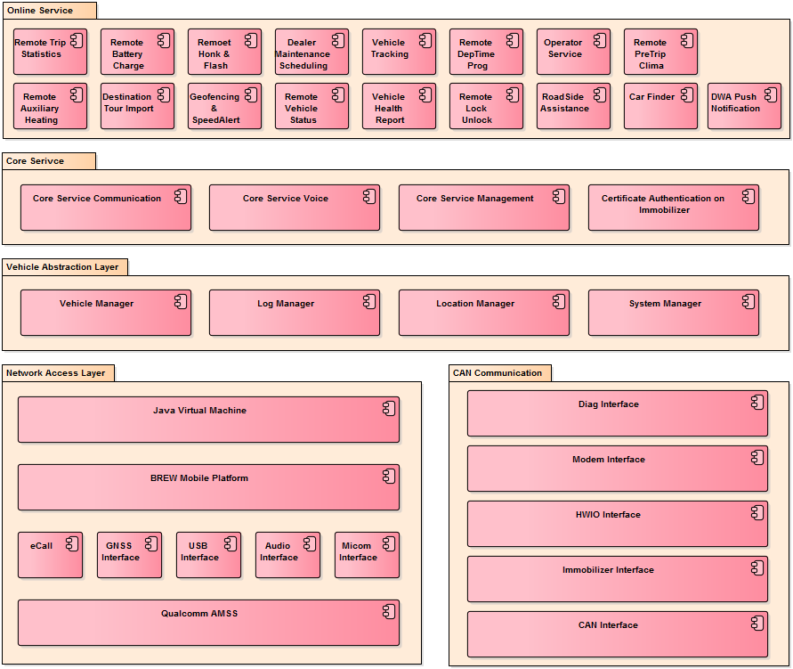

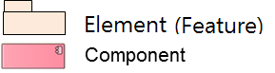

Figure 4.1 Module View

|  |
| --- |
| Make a list for the identified SW Modules.  • SAD/SW Module -> SRS_ID Traceability: Traceability can be managed more easily by managing it in a separate Excel file or requirements management tool.  • Dev Type: Indicate the classification of reuse, purchase (COTS), outsourced development, etc. |

Below table describes the software components which are specified in Chapter 2.1.

Table 4.1SW Component Catalog

|  |  |  |  |  |  |
| --- | --- | --- | --- | --- | --- |
| Layer | SW Component ID | SW Component Name | Description | **Dev Type** | **Owner** |
| App | SWC-001 | Remote Trip Statistics | Vehicle’s trip information (mileage, average consumption) | LGE |  |
| SWC-002 | Remote Battery Charge | To control e-vehicle’s battery charging function remotely | Reuse |  |
|  |  |  | COTS |  |
|  |  |  | Out sourcing |  |
|  |  |  |  |  |
|  |  |  |  |  |  |
|  |  |  |  |  |
|  |  |  |  |  |  |
|  |  |  |  |  |  |

## C&C View

|  |
| --- |
| • (Mandatory) Define the SW Architecture in the form of Component & Connector for the target SW, and describe the connection relationship and communication method between components. Component of C&C View refers to the processing unit (Component, Process, Task, etc.) executed in the system. Component types include Client, Server, Filter, Object, DB, etc.  • (Mandatory) The interface identified here shall not violate Chapter 5 Interaction Design.  • (Optional) C&C View can be described in subclauses for each feature. |

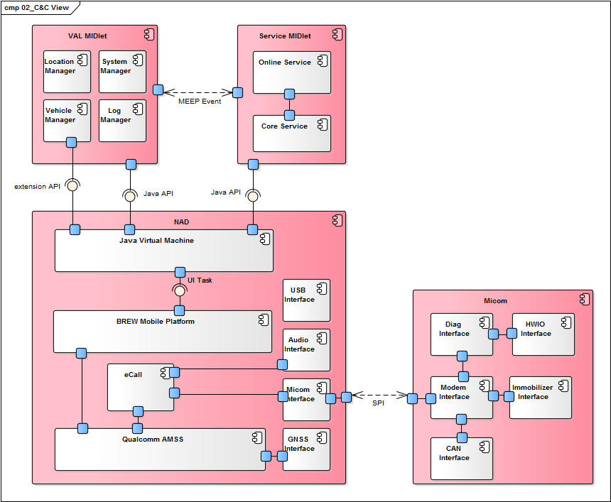

Figure 4.2 C&C View

The above diagram is mainly expressed with the components composing the OCU architecture and the connectors that connect the components.

1. Service MIDlet consists of Java Online Service and Java Core Service and uses Java standard API.…
2. …
3. …

### Component Design

|  |
| --- |
| * (Mandatory) Organize the component, the execution unit identified in the C&C view. Since the execution unit varies depending on the environment such as the OS and development language, the process/task can be designed according to each environment. |

|  |  |  |  |  |
| --- | --- | --- | --- | --- |
| **Component**  **Type** | **Component Name** | **Description** | **Constraints** | **Related**  **SW Module** |
| Process/Task | task name | Describe what the task is. | In general, the contents described in constraints include the following items.  - Cycle Time  - Processing Time  - Memory Usage (Heap, Stack size)  - Scheduling priority  This is an item defined as a property when creating processes/threads, mainly in code or configuration file. | If Module and Component are different, they are mapped. |

Table 4.2 SW Component catalogue

|  |  |  |  |  |
| --- | --- | --- | --- | --- |
| Component Type | Component ID/Name | Description | Constraints | Related SW Module |
| Process | SWC-01  AppManager | This task runs as a process, and receives requests for resuming and pausing Applications. | Cycle time: n/a (request basis processing)  Processing time: Maximum startup time to start last audio/video source is 10 seconds. | AppManager |
| Process | SWC-02  AppLauncher | … | ... | … |

## Allocation View

|  |
| --- |
| (Mandatory) Based on the C&C view defined in Section 4.2 of this document, the SW Architecture in the form of a Deployment view that expresses the relationship between SW and HW composing the system is defined and major considerations are described. |

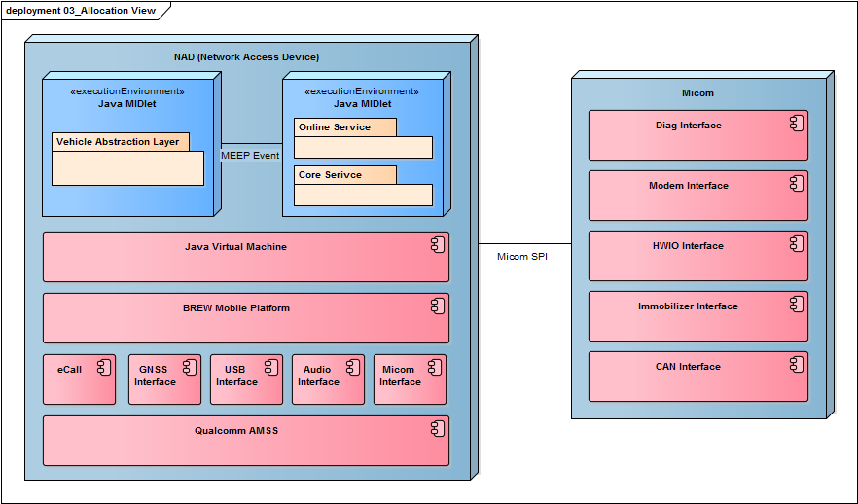

Figure 4.3 Deployment View

|  |
| --- |
| (Optional) Write the components allocated for each process in a table.  Note: If Dev Type and Owner in Table 4.3 overlap with Table 4.1, delete them. |

Table 4.3 SW Component Allocation Table

|  |  |  |  |  |
| --- | --- | --- | --- | --- |
| Processor | SW Component ID | SW Component Name | **Dev Type** | **Owner** |
| MCU | SWC-001 | Remote Trip Statistics |  |  |
| SWC-002 | Remote Battery Charge |  |  |
|  |  |  |  |
| APP |  |  |  |  |

|  |
| --- |
| (Optional) If the above figure has no special meaning, the actual location of the source code can be listed for each component.  Note: If Dev Type and Owner in Table 4.4 overlap with Table 4.1, delete them. |

Table 4.4 SW Component Source Location

|  |  |  |  |  |  |
| --- | --- | --- | --- | --- | --- |
| Processor | SW Component ID | SW Component Name | Source Code Location | **Dev Type** | **Owner** |
| MCU | SWC-001 | Remote Trip Statistics |  |  |  |
| SWC-002 | Remote Battery Charge |  |  |  |
|  |  |  |  |  |
|  |  |  |  |  |
|  |  |  |  |  |
| APP |  |  |  |  |  |

# Interaction Design

|  |
| --- |
| 1) (Mandatory) 3.2 Based on the C&C view, allocate the requirements defined in SRS (use case) to each component, and define the interface (message or call) between them as a sequence diagram. (If UC is not used for SRS, the necessary scenarios are identified based on SRS.)  2) Add a description to all messages defined in the sequence diagram and give SRS_ID traceability.  3) Since Interaction Design is the basis of SW Integration test, the range value of all message parameters should be clearly defined in Chapter 6.  4) If there are many requirements, it is not appropriate to draw all sequence diagrams in SAD, so it can be written as a separate document for each feature. [12]  5) How to write Step Description  - The step number that becomes a prerequisite is like 0.1, 0.2.  - The external input is pasted as 1.0.  - Internal processing is applied in the order of 1.1 and 1.2.  6) If there is a separate input, attach it as 2.0. |

## Feature1

### Scenario1 or SD for UCx.y

< Sequence diagram makes end-to-end appear including actors and components defined in C&C view. When you include a reference, you include an interface. Can be omitted if the meaning is clear >



Figure 5.1 SD for Secnario1 or UCx.1

This diagram is … … is the flow for.

Step Description

< The diagram description is written step by step, and the related SRS_ID is written in parentheses at the end.

Basic flow, Alternative flow, and exception of SRS are also included.>

1.0 Activate Power Save Mode

1.1 Send message to DiagnosticService

1.2 Send message to HETService

1.3 HET service Enable Power Save Mode (UC10.1_28, UC10.1_32)

1.4 Turn on IR LED (UC10.1_29, UC10.1_33)

1.5 Turn on Image Sensor of Camera (UC10.1_30, UC10.1_34)

1.6 Turn off Algorithm unit and return result (UC10.1_31)

1.7 Return result (UC10.1_33, UC10.1_34, UC10.1_35)

### Scenario2 or SD for UCx.y

< When defining a repeated section and using it as a reference, an interface is included.>



Figure 5.2 SD for Secnario2 or UCx.2

## Feature2

# Interface Design

|  |
| --- |
| 1) All interfaces identified through the process of Chapter 4 (by scenario) or (by component) are described in table form.  2) When writing (by scenario) If there are many components/interfaces, the amount of SAD document becomes too large and readability is reduced, so it can be described as a separate document for each feature. [12]  3) In case of writing (by component), interface design can be described by transferring it to 2. External interfaces of SDD. (In this case, it is specified in section 1.4 Convention to refer to SDD.)  There is also a way to describe interfaces such as device drivers with stable interfaces in SAD, and interfaces such as applications with many changes to SDD only.  4) For the convenience of writing Software Integration test case, the table of contents of Chapter 6 is the same as that of Chapter 5. |

## Interfaces of Scenario1 or UCx.1

|  |
| --- |
| (Mandatory) Defines the interface for each Feature or Component (which receives messages). Be sure to write the range for parameter/return. |

|  |  |  |  |
| --- | --- | --- | --- |
| **SW Component Name** | Interface Name | **Type** | **Parameters (range)** |
| Component Name | interface name | Use one of the values below (can be added)  - message: asynchronous communication  - call: call a local function  - dbus: Communication using dbus  - LIN: | In/Out Parameter Description, Range |

This section specifies the interface related to Application Launcher.

|  |  |  |  |
| --- | --- | --- | --- |
| SW Component Name | Interface Name | Type | Parameters |
| Application Loader | MakeLaunchAppList | call | In:   * context data: LUC, country information, car variant   Out:   * Boot sequence list: list in which order the Application shall be started |
| … | … | … |
| AppProcess | launch | call | N/A |
| checkRestart | call | In:   * Restart count: the restart number until now |
| Logger | log | call | In:   * Data: data to be logged |

## Interfaces of Scenario2 or UCx.2

# Resource Consumption Objectives

|  |
| --- |
| (Mandatory) Estimate the resources CPU, Runtime Memory, and ROM Memory required for each SW Component identified in Chapter 4.  During the development period, it includes the person in charge of the actual resource use result, the measurement method, the measurement cycle, and the method of reporting the measurement result. |

|  |  |  |  |  |  |  |
| --- | --- | --- | --- | --- | --- | --- |
| **Feature** | SW Component Name | **CPU Load** | **CPU Load** | **Runtime Memory** | ROM Size | Remarks |
| Feature Name | Component Name | CPU load of the component (%) | CPU load of the element (%) | Runtime memory size of the element | ROM size of the element | Remarks |

Below table shows the estimated CPU load, runtime memory and rom memory for each software components.

Overall worst case scenario: Write the maximum resource use scenario.

Table 7.1 Resource Consumption Objectives

|  |  |  |  |  |  |  |
| --- | --- | --- | --- | --- | --- | --- |
| Feature | SW Component ID | SW Component Name | CPU Load | CPU Load | Runtime Memory | ROM Size |
| Online Service | XXX_SWC-001 | Remote Trip Statistics | 15% | 30% | OO MB | OO MB |
| XXX_SWC-002 | Remote Battery Charge | … |
|  | … | … |
|  |  |  | 3% | 40% | OO MB | OO MB |
|  |  | … |
|  |  | … |
|  |  | … |
|  |  | … |
|  |  | … |
|  |  |  | 10% | 70% | OO KB | OO KB |
|  |  | … |
|  |  | … |
|  | … | … |
|  | … | … |

# Design Alternatives

|  |
| --- |
| (Optional) Among the quality requirements listed in Section 2.2 Quality Attributes of this document, scenario refinement is performed for those with high business and technical priorities, and design alternatives to achieve this are selected, and trade-off analysis is performed. decide through |

## Scenario N: Quality Attribute [예: Scenario #1: Performance]

|  |  |  |  |  |  |  |  |  |  |  |  |  |
| --- | --- | --- | --- | --- | --- | --- | --- | --- | --- | --- | --- | --- |
| **QA Type** | **Quality Attribute Scenario** | | | | | | | | | | **Priority** | |
| QA type | Describe the scenario (SyRS_ID) | | | | | | | | | | High | |
| Business Goal | Describe the business goals that are affected by the scenario | | | | | | | | | | | |
| **Source** | **Stimulus** | | **Artifacts** | | | **Environment** | | **Response** | | | **Measure** | |
| source of stimulation | stimulus that causes a response in the system | | System components that respond to stimuli | | | The environment in which the stimulus that causes the system to respond occurs | | Response of system components to stimuli | | | Response metric | |
| Architectural Decisions and Reasoning | List design alternatives.  Alternative #1: …  Alternative #2: …  Choice : #1  Rationale: Describes design decisions related to the given scenario that affect the quality attribute response. Discuss the rationale for making the design decision. | | | | | | | | | | | |
| Allocated SW Component | SW components related to the design | | | | | | | | | | | |
| Trade-off  Analysis | Alternative | time to market | | Cost | Risk | | System qualities | | Reuse | Use proven technologies | | Performance |
| #1 | **Yes** | | **Yes** | No | | NO | | **Yes** | Unknown | | No |
| #2 | No | | No | **Yes** | | **Yes** | | Unknown | Yes | | Unknown |

< Draw a picture of the selected design alternative(mandatory) and alternative design alternative(optional)>

Figure 8.1 Alternative Design #1

## Ecall trigger: Performance (예)

|  |  |  |  |  |  |  |  |  |  |  |  |  |
| --- | --- | --- | --- | --- | --- | --- | --- | --- | --- | --- | --- | --- |
| **QA Type** | **Quality Attribute Scenario** | | | | | | | | | | **Priority** | |
| Performance | The IVS shall generate an eCall within 1 sec after the confirmed triggering signal is received. (SyRS_ID) | | | | | | | | | | High | |
| Business Goal | Describe the business goals that are affected by the scenario | | | | | | | | | | | |
| **Source** | **Stimulus** | | | **Artifacts** | | **Environment** | | | **Response** | | **Measure** | |
| Airbag or Button | Airbag deployment signal / Emergency call button pressed | | | 시스템 | | Car accident or emergency situation | | | Trigger eCall after receiving the airbag or button signal. | | Within 1 sec after receiving the signal. | |
| **Architectural Elements** | eCall / CAN Interface / HWIO Interface / Modem Interface / Micom Interface / Audio Interface | | | | | | | | | | | |
| Architectural Decisions and Reasoning | Time required for communicating between Micom and NAD using SPI 🡪 Airbag crash signal is set to high priority.  Time required for communicating with MIB to secure audio path 🡪 If there is no response from MIB within OOO seconds, set HW mute and change to use local loud speaker.  Risk :  1) Low priority services may be blocked  2) If converting to local loud speaker gets delayed, eCall sound may not be heard properly. | | | | | | | | | | | |
| Allocated SW Component | SW components related to the design | | | | | | | | | | | |
| Trade-off  Analysis | Alternative | time to market | Cost | | Risk | | System qualities | Reuse | | Use proven technologies | | Performance | |
| #1 | **Yes** | **Yes** | | No | | NO | **Yes** | | Unknown | | No | |
| #2 | No | No | | **Yes** | | **Yes** | Unknown | | Yes | | Unknown | |

< Draw a picture of the selected design alternative (mandatory) and alternative design alternative (optional).>

## Scenario N: Quality Attribute

# Future Extension

<Optional: This chapter describes matters to be considered for future system expansion and matters to be reflected in the structure. >

## Considerations

## Architecture